**Step 1: Create and Configure the initial topology**

1. In Packet Tracer turn simulation on – click on the SHOW NONE to clear the list, then click on EDIT FILTERS so you only filter ICMP frames
2. Create the below topology.
3. Configure all PC’s and routers – IP addresses, subnet masks, default gateways, etc.
4. Configure RIPv2 on all routers.   
   *NOTE: there should be NO static routes!*
5. Once complete ensure that all PC’s can ping each other before proceeding   
   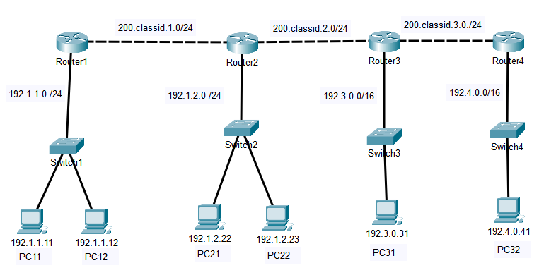

**Step 2: Create and Configure ACL’s**

You will now create and configure ACL’s based on the requirements below. Make sure you understand the requirements and how the topology works. Remember, you need to create the correct ACL and then configure it to the correct router and router port.

**NOTE: CREATE ACL’s ON ONLY ROUTERS 2 AND 3**. Do not create ACL’s on any other router.

Hint: When numbering your ACLs, use numbers that corespond to the router number and port: For example ACL 21 – Router 2 port 1

**Requirements:**

1. Block packets from subnets 192.1.1.0 and 192.1.2.0 to switch3, but allow them to Router 4. Note: Use a single ACL sequence command (ie: use a mask)
2. Allow all packets except PC11 (192.1.11) and PC31 (192.3.0.31) to switch2
3. Allow only PC22 and subnet 192.4.0.0 to switch1.

**Step 3: Lab Completion**

1. Save your packet file as Lab10b-Lastname and submit via iLearn.